REFILOE MOFUBETSOANA

28563646

1.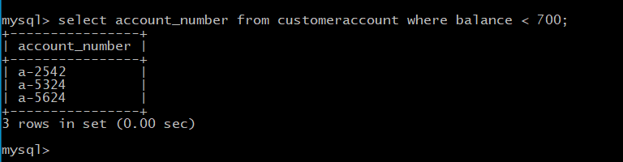

2.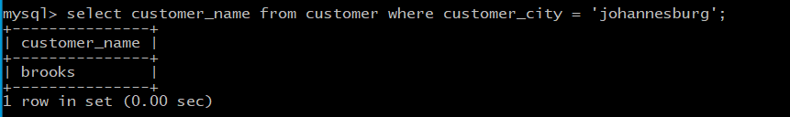

3.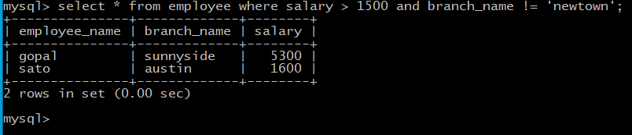

4.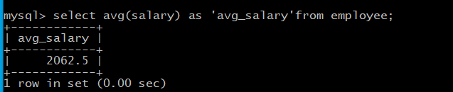

5.

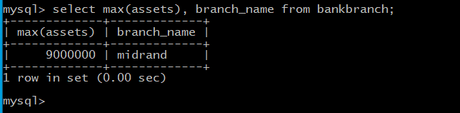

Question 2

1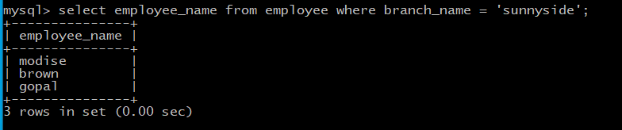

2.

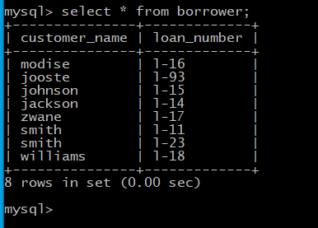

3.



4.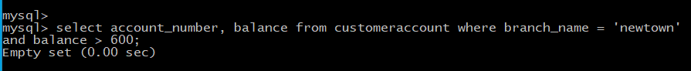

5.